**The Spiritual Rule**

A **____________________** is a pattern of **______________**that provides **_____________** and direction for growth in **_________**

The practice of a spiritual rule of life is maintaining a **_____________**of continual **________________**to God

**Warning:** The Spiritual Rule in itself has no power in it!

It only provides you with the **____________**to open your heart to receive the grace of God!

2 Kings 3:15-24 Dig some ditches!

**“The spiritual rule” is a way to ______ into the heart to ___________any unclean thing in it**

* Grace will come when you **____________________** to receive it
* When the valley of your heart is filled with water, you will have_____________________ to **__________________**in your life

**“So it was, from that time on, *that* half of my servants worked at construction, while the other half held the spears, the shields, the bows, and *wore* armor; and the leaders *were* behind all the house of Judah. 17Those who built on the wall, and those who carried burdens, loaded themselves so that with one hand they worked at construction, and with the other held a weapon. 18Every one of the builders had his sword girded at his side as he built. And the one who sounded the trumpet *was* beside me.” Nehemiah 4:16-18**

The Spiritual Rule builds _____________ around the heart

**The spiritual rule of life helps change the _________ of your ________**

Through discipline, you prevent yourself from letting your will __________ away from _____________

**How to establish a spiritual rule**

1. **Sit with your ___________________**

***“The way of a fool is right in his own eyes, but he who heeds counsel is wise.” Proverbs 12:15***

1. **_________ reading in the Bible**

**“You are already clean because of the word which I have spoken to you.” John 15:3**

1. **Read the ________ at least once a day (____________ the Psalms**

“Now when Daniel knew that the writing was signed, he went home. And in his upper room, with his windows open toward Jerusalem, he knelt down on his knees three times that day, and prayed and gave thanks before his God, as was his custom since early days.” Daniel 6:10

1. **______________**

“14For this reason I bow my knees to the Father of our Lord Jesus Christ,” Ephesians 3:14

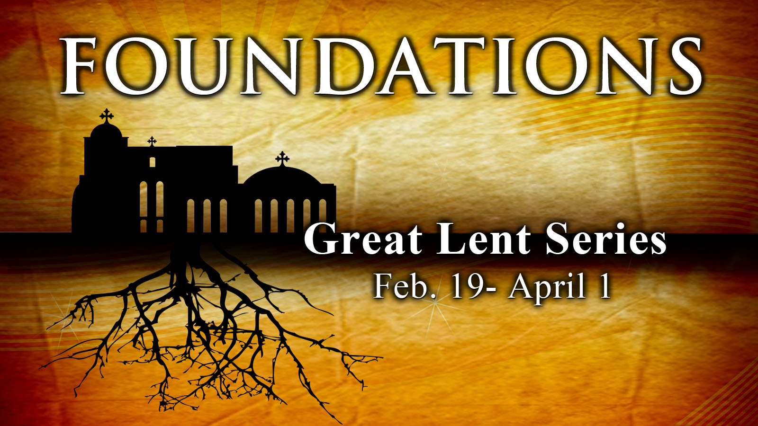

The Spiritual Rule of Life

Foundations

Part 2

February26, 2012