**The Armor of Integrity**

*“Therefore take up the whole armor of God, that you may be able to withstand in the evil day, and having done all, to stand. Stand therefore, having girded your waist with truth, having put on the breastplate of righteousness and having shod your feet with the preparation of the gospel of peace”* Ephesians 6:13-15

*“Be sober, be vigilant; because your adversary the devil walks about like a roaring lion, seeking whom he may devour.”* 1 Peter 5:8

**I must prepare when I am ________________**

**in order to resist when I am _______________**

*“Therefore let him who thinks he stands take heed lest he fall.”* 1 Corinthians 10:12

**Belt of Truth and Breastplate of Righteousness:**

**_________________________**

**WHY SO IMPORTANT**

* **A life of integrity is a life of _____________________**

*“The righteousness of the blameless will direct his way aright, but the wicked will fall by his own wickedness. The righteousness of the upright will deliver them, but the unfaithful will be caught by their lust.”* Proverbs 11:5-6

*“He who walks with integrity walks securely, but he who perverts his ways will become known.”* Proverbs 10:9

* **A life lacking integrity is a __________________________**

*“But let your ‘Yes’ be ‘Yes,’ and your ‘No,’ ‘No.’ For whatever is more than these is from the evil one.”* Matthew 5:37

**How to live a life of integrity?**

1. **Belt of Truth: __________________________________**

*“Lying lips are an abomination to the LORD, but those who deal truthfully are His delight.”*  Proverbs 12:22

*“that we…speaking the truth in love, may grow up in all things into Him who is the head—Christ”* Ephesians 4:15

*“Put away from you a deceitful mouth, and put perverse lips far from you.”* Proverbs 4:24

1. **Breastplate of Righteousness: _________________________**

*“In the way of righteousness is life, and in its pathway there is no death.”*  Proverbs 12:28

*“But King Solomon loved many foreign women, as well as the daughter of Pharaoh: women of the Moabites, Ammonites, Edomites, Sidonians, and Hittites — from the nations of whom the LORD had said to the children of Israel, “You shall not intermarry with them, nor they with you. Surely they will turn away your hearts after their gods.” Solomon clung to these in love.”* 1 Kings 11:1-2

*“For it was so, when Solomon was old, that his wives turned his heart after other gods; and his heart was not loyal to the LORD his God, as was the heart of his father David.”* 1 Kings 11:4

*“The mouth of the righteous brings forth wisdom… The lips of the righteous know what is acceptable, but the mouth of the wicked what is perverse.”* Proverbs 10:31-32

**__________ holes sink ____________ships**

*“that you may become blameless and harmless, children of God without fault in the midst of a crooked and perverse generation, among whom you shine as lights in the world”* Philippians 2:15

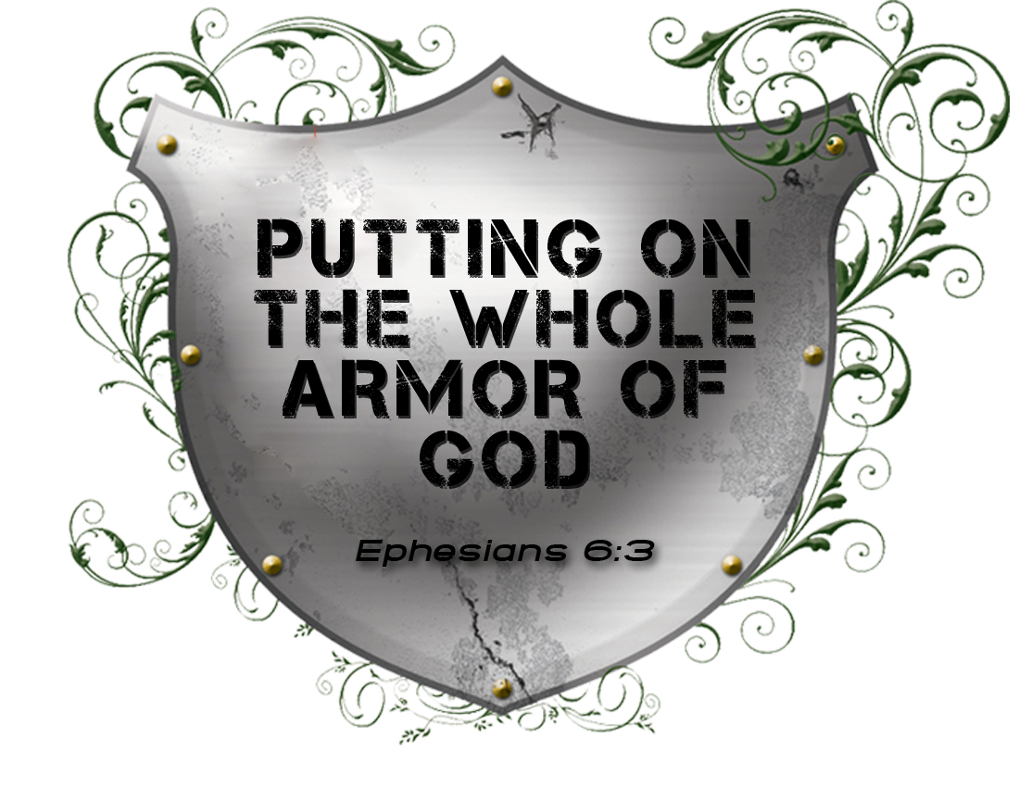The Armor of Integrity

Spiritual Warfare – Part 5

March 14, 2010