**What’s So Special about Christmas?**

1. **THE RELEVANCE: _________________________________**

*“He [Jesus Christ] is the image of the invisible God, the firstborn over all creation...All things were created through Him and for Him”* Colossians 1:15, 16

*“For there is one God and one Mediator between God and men, the Man Christ Jesus”*  1 Timothy 2:5

1. **THE REASON: ___________________________________**

*“I have come that they may have life, and that they may have it more abundantly.”*  John 10:10

*“… He was manifested to take away our sins...”*  1 John 3:5

*“Mercy and truth have met together; righteousness and peace have kissed.”* Psalm 85:10

*“Greater love has no one than this, than to lay down one's life for his friends.”* John 15:13

1. **THE RESULT: __________________________________**

*“For if when we were enemies we were reconciled to God through the death of His Son, much more, having been reconciled, we shall be saved by His life. And not only that, but we also rejoice in God through our Lord Jesus Christ, through whom we have now received the reconciliation.”* Romans 5:10-11

***The perfect gift – what to do with it?***

*“Therefore God also has highly exalted Him and given Him the name which is above every name, that at the name of Jesus every knee should bow, of those in heaven, and of those on earth, and of those under the earth, and that every tongue should confess that Jesus Christ is Lord, to the glory of God the Father”* Philippians 2:9-11

**JESUS IS LORD!**

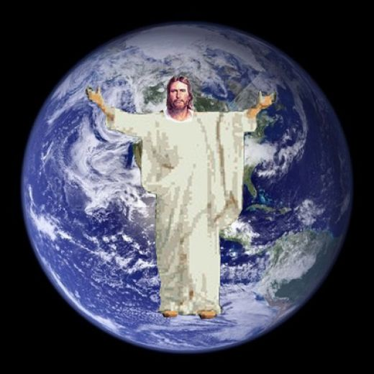



What’s So Special

about Christmas?

December 26, 2010