This Is WAR!!!

“There are two equal and opposite errors into which our race can fall about the devils. One is to disbelieve in their existence. The other is to believe, and to feel an excessive and unhealthy interest in them. They themselves are equally pleased by both errors and hail a materialist or a magician with the same delight.” C.S. Lewis

Bad News: YOU ARE IN AN ___________________ WAR RIGHT NOW

“Be sober, be vigilant; because your adversary the devil walks about like a roaring lion, seeking whom he may devour.” 1 Peter 5:8

“For what I am doing, I do not understand. For what I will to do, that I do not practice; but what I hate, that I do.” Romans 7:15

Good News: THE BATTLE BELONGS TO ______________________

“for the battle is the LORD’s, and He will give you into our hands.” 1 Samuel 17:47

Spiritual Warfare is “conflict waged in the invisible, spiritual realm that is manifest in the visible, physical realm”

“For we do not wrestle against flesh and blood, but against principalities, against powers, against the rulers of the darkness of this age, against spiritual hosts of wickedness in the heavenly places.” Ephesians 6:12
Principles of spiritual warfare

- there is an _____________________ world

“[the power] …which He worked in Christ when He raised Him from the dead and seated Him at His right hand in the heavenly places” Ephesians 1:20

“When the servant of the man of God arose early and went out, there was an army, surrounding the city with horses and chariots. And his servant said to him, “Alas, my master! What shall we do?” So he answered, “Do not fear, for those who are with us are more than those who are with them.” And Elisha prayed, and said, “LORD, I pray, open his eyes that he may see.” Then the LORD opened the eyes of the young man, and he saw. And behold, the mountain was full of horses and chariots of fire all around Elisha.” 2 Kings 6:15-17

“My son, if you come to serve the Lord, prepare your soul for temptation.” Sirach 2:1

- our enemy: _________________him, but do not _________him

“The thief does not come except to steal, and to kill and to destroy.” John 10:10

“Put on the whole armor of God, that you may be able to stand against the wiles of the devil.” Ephesians 6:11
“For if indeed I have forgiven anything, I have forgiven that one for your sakes in the presence of Christ, lest Satan should take advantage of us; for we are not ignorant of his devices.” 2 Corinthians 2:10-11

- we don’t fight _______ victory, we fight ________ victory

“Now is the judgment of this world; now the ruler of this world will be cast out.” John 12:31

“having wiped out the handwriting of requirements that was against us, which was contrary to us. And He has taken it out of the way, having nailed it to the cross. Having disarmed principalities and powers, He made a public spectacle of them, triumphing over them in it.” Colossians 2:14-15

“And He said to them, “I saw Satan fall like lightning from heaven. Behold, I give you the authority to trample on serpents and scorpions, and over all the power of the enemy, and nothing shall by any means hurt you.” Luke 10:18-19

“Finally, my brethren, be strong in the Lord
and in the power of His might.”
Ephesians 6:10

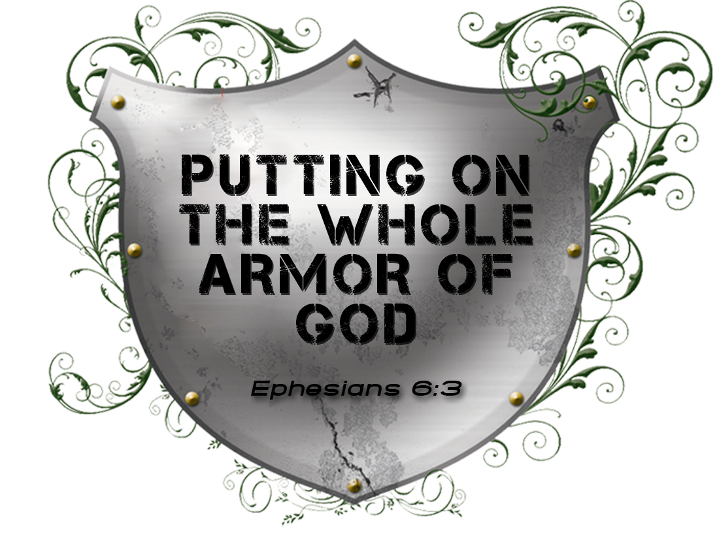

The War is On!
Spiritual Warfare – Part 1
February 14, 2010

