**The Lord is My Shepherd**

**Psalm 23**

The LORD is my shepherd, I shall not be in want. He makes me lie down in green pastures, he leads me beside quiet waters, he restores my soul. He guides me in paths of righteousness for his name’s sake. Even though I walk through the valley of the shadow of death, I will fear no evil, for you are with me; your rod and your staff, they comfort me.

**The Pinnacle of Spirituality = ______________**

*“Those who trust in the LORD are like Mount Zion, which cannot be shaken but endures forever.”* Psalm 125:1

**what does it mean to TRUST god?** – see John 4:46-54

1. ____________________, based on _____________________
2. ____________________, based on _____________________
3. ____________________, based on _____________________

**_____________________God ≠ _____________________God**

Book to Read: Hinds Feet on High Places

*“The LORD God is my strength; He will make my feet like deer’s feet, and He will make me walk on my high hills.”* Habakkuk 3:19

**Trust is the only path to ___________________________**

*“Now He did not do many mighty works there because of their unbelief.”* Matthew 13:58

**________________________ is the only way to gain trust**

*“The believer does not enter into an argument with God about His doing, but accepts all things and confidence in God's wisdom and love.”* H.H. Pope Shenouda III

***Are you ready to trust Him up the mountain?***

*“Jesus said to him, “If you can believe, all things are possible to him who believes.”*

Mark 9:23

**John 4:46-54**

46 So Jesus came again to Cana of Galilee where He had made the water wine. And there was a certain nobleman whose son was sick at Capernaum.

47 When he heard that Jesus had come out of Judea into Galilee, he went to Him and implored Him to come down and heal his son, for he was at the point of death.

48 Then Jesus said to him, “Unless you people see signs and wonders, you will by no means believe.”

49 The nobleman said to Him, “Sir, come down before my child dies!”

50 Jesus said to him, “Go your way; your son lives.” So the man believed the word that Jesus spoke to him, and he went his way.

51 And as he was now going down, his servants met him and told him, saying, “Your son lives!”

52 Then he inquired of them the hour when he got better. And they said to him, “Yesterday at the seventh hour the fever left him.”

53 So the father knew that it was at the same hour in which Jesus said to him, “Your son lives.” And he himself believed, and his whole household.

54 This again is the second sign Jesus did when He had come out of Judea into Galilee.

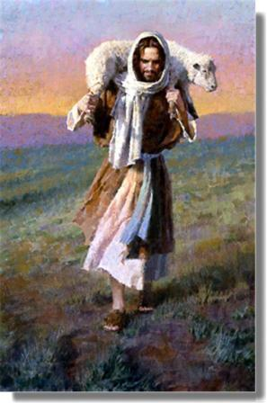

The Lord is My Shepherd

April 10, 2011