**I believe in God, but I don’t know Him**

**PRACTICAL ATHEIST: someone who believes in God, but lives as if He doesn’t exist.**

*“They claim to know God, but by their actions they deny him. They are detestable, disobedient and unfit for doing anything good.”* Titus 1:16

***What does it mean to know God?***

**SOME BELIEVE IN GOD…**

**• BUT DON’T _______________________**

*“Now by this we know that we know Him, if we keep His commandments. He who says, “I know Him,” and does not keep His commandments, is a liar, and the truth is not in him.”* 1 John 2:3-4

*“Not everyone who says to Me, ‘Lord, Lord,’ shall enter the kingdom of heaven, but he who does the will of My Father in heaven. Many will say to Me in that day, ‘Lord, Lord, have we not prophesied in Your name, cast out demons in Your name, and done many wonders in Your name?’ And then I will declare to them, ‘I never knew you; depart from Me, you who practice lawlessness!’”* Matthew 7:21-23

**• AND KNOW HIM, BUT DON’T __________________________**

*“But then, indeed, when you did not know God, you served those which by nature are not gods. But now after you have known God, or rather are known by God, how is it that you turn again to the weak and beggarly elements, to which you desire again to be in bondage?”* Galatians 4:8-9

• **KNOW HIM ____________________& _____________ HIM WHOLEHEARTEDLY**

*“And you will seek Me and find Me, when you search for Me with all your heart.”* Jeremiah 29:13

*“God, you are my God, earnestly I seek you; my soul thirsts for you, my body longs for you, in a dry and weary land where there is no water. I have seen you in the sanctuary and beheld your power and your glory. Because your love is better than life, my lips will glorify you. I will praise you as long as I live, and in your name I will lift up my hands.*” Psalm 63:1-4

*“Those who know your name will trust in you, for you, LORD, have never forsaken those who seek you.”*  Psalm 9:10

*“Taste and see that the LORD is good”*  Psalm 34:8

**MY PRAYER FOR YOU**

*“that the God of our Lord Jesus Christ, the Father of glory, may give to you the spirit of wisdom and revelation in the knowledge of Him, the eyes of your understanding being enlightened; that you may know what is the hope of His calling, what are the riches of the glory of His inheritance in the saints, and what is the exceeding greatness of His power toward us who believe”* Ephesians 1:17-19

**Personal Meditation Questions**

1. Some people believe in God, but don’t know Him. Some know Him, but not well. Some know Him intimately and seek Him wholeheartedly. Which one are you?
2. What are some ways you can become more intimate with God.
3. What is the biggest thing God has shown you through the Practical Atheist series?

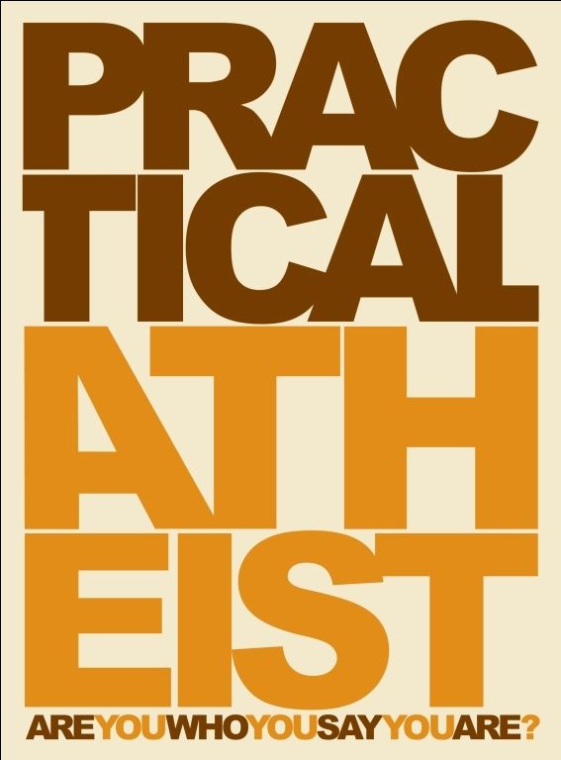

I Believe in God,

but I Don’t Know Him

October 17, 2010

Part 4