**Quit Living in Fear**

**LIFE’S MOST COMMON FEARS**

_____ Fear of Loss

_____ Fear of Failure

_____ Fear of Rejection

_____ Fear of the Unknown

*“For God has not given us a spirit of fear, but of power and of love and of a sound mind.”* 2 Timothy 1:7

***What is fear?***

**Fear is placing faith in the “_____________________?”**

*“Moses answered, "What if they do not believe me or listen to me and say, 'The Lord did not appear to you'?"* Exodus 4:1

***Why do your “what ifs” matter?***

* **What you fear reveals what you _______________________**
* **What you fear reveals where you ______________________**

I am not trusting God with ______________________

**FACING THE “WHAT IFS” OF FEAR**

1. **____________________ your fear and choose to ____________________**

*“My slanderers pursue me all day long; many are attacking me in their pride. When I am afraid, I will trust in you. In God, whose word I praise, in God I trust; I will not be afraid. What can mortal man do to me?”*  Psalm 56:2-4

*“And do not fear those who kill the body but cannot kill the soul”*  Matthew 10:28

1. **_______________ UNTIL HE TAKES AWAY YOUR FEARS**

*“I sought the LORD, and He heard me, and delivered me from all my fears.”* Psalm 34:4

*"I have never known more than fifteen minutes of anxiety or fear. Whenever I feel fearful emotions overtaking me I just close my eyes and thank God that he is still on the throne reigning over everything and I take comfort in His control over all the affairs of my life.”*

***“For you did not receive the spirit of bondage again to fear, but you received the Spirit of adoption by whom we cry out, "Abba, Father."”***

Romans 8:15

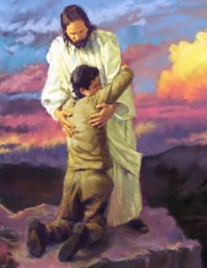



Quit Living in Fear

February 13, 2011

I Quit – Part 3