**How God Builds Your Faith**

*"According to your faith, let it be to you.”* Matthew 9:29

*“Jesus said to him, ‘If you can believe, all things are possible to him who believes.’”* Mark 9:23

**How Does God Build My Faith?**

**PHASE 1:___________________________________________**

*“Now to Him who is able to do exceedingly abundantly above all that we ask or think, according to the power that works in us*” Ephesians 3:20

**PHASE 2:___________________________________________**

“And the Lord said to Moses, Why do you cry to Me? Tell the children of Israel to go forward.” Exodus 14:15

**PHASE 3:___________________________________________**

*“For the vision is yet for an appointed time; but at the end it will speak, and it will not lie. Though it tarries, wait for it; because it will surely come”* Habakkuk 2:3

**PHASE 4:___________________________________________**

*“In this you greatly rejoice, though now for a little while, if need be, you have been grieved by various trials, that the genuineness of your faith, being much more precious than gold that perishes, though it is tested by fire, may be found to praise, honor, and glory at the revelation of Jesus Christ,”* 1 Peter 1:6-7

**PHASE 5:___________________________________________**

*“We were burdened beyond measure, above strength, so that we despaired even of life. Yes, we had the sentence of death in ourselves, that we should not trust in ourselves but in God who raises the dead”*  2 Corinthians 1:8-9

**PHASE 6:___________________________________________**

*“…who delivered us from so great a death, and does deliver us; in whom we trust that He will still deliver us”* 2 Corinthians 1:10

**Psalm 27:1-3**

*“The Lord is my light and my salvation; whom shall I fear? The Lord is the strength of my life; of whom shall I be afraid? When the wicked came against me to eat up my flesh, my enemies and foes, they stumbled and fell. Though an army may encamp against me, my heart shall not fear; though war should rise against me, in this I will be confident.”*

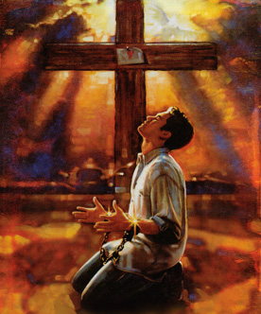

How God Builds Your Faith

May 1, 2011