The Living Word of God

“But you must continue in the things which you have learned and been assured of, knowing from whom you have learned them, and that from childhood you have known the Holy Scriptures, which are able to make you wise for salvation through faith which is in Christ Jesus.” 2 Timothy 3:14-15

“For the word of God is living and powerful, and sharper than any two-edged sword, piercing even to the division of soul and spirit, and of joints and marrow, and is a discerner of the thoughts and intents of the heart.” Hebrews 4:12

The goal of reading the bible is a ___________________________________________

Why? Because the Bible is the _______________ tool by which we know God.

going deeper in the Word

- ________________ my Bible

“…It shall be with him, and he shall read it all the days of his life, that he may learn to fear the LORD his God and be careful to observe all the words of this law…” Deuteronomy 17:19

“Blessed is he who reads and those who hear the words of this prophecy, and keep those things which are written in it” Revelation 1:3

- ________________ my Bible

“Jesus answered and said to them, “You are mistaken, not knowing the Scriptures nor the power of God.” Matthew 22:29
THE BIBLE FOR DUMMIES

Old Testament Facts
- Law
- History
- Poetry
- Major Prophets
- Minor Prophets

New Testament Facts
- Gospels
- Acts
- Pauline Epistles
- Catholic Epistles
- Revelation

“Your words were found, and I ate them, and Your word was to me the joy and rejoicing of my heart” Jeremiah 15:16

“A Bible which is falling apart usually
belongs to someone who isn’t”

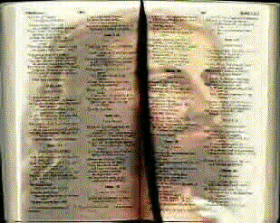

The Living
Word of God
March 4, 2012

