God? Man? Or All of the Above?

“His Divinity parted not from His humanity for a single moment nor a twinkling of an eye…” [HYPOSTATIC UNION]

“…without controversy great is the mystery of godliness: God was manifested in the flesh,” 1 Timothy 3:16

One Nature of the ______________________________

St. Cyril of Alexandria

Divinity and Humanity united
“without mingling, confusion or alteration…”

100% ________ & 100% ________, 100% of the ________

Implications of this United Nature

- He experienced a human ____________________

“And Jesus increased in wisdom and stature, and in favor with God and men.” Luke 2:52
- He experienced human ____________________

“Jesus wept” John 11:35

“In that hour Jesus rejoiced in the Spirit…” Luke 10:21

“When Jesus heard it, He marveled…” Matthew 8:10

“And when He had looked around at them with anger, being grieved by the hardness of their hearts…” Mark 3:5

- he experienced human ____________________

“Jesus therefore, being wearied from His journey, sat thus by the well.” John 4:6

Did He have two wills? Or one will?

“For I have come down from heaven, not to do My own will, but the will of Him who sent Me.” John 6:38

“But we have the mind of Christ.” 1 Corinthians 2:16

Monophysite or Miaphysite?

Why is this important?

- My ____________________ depends on it

- It revealed ____________ to man.

“No one has seen God at any time. The only begotten Son, who is in the bosom of the Father, He has declared Him.” John 1:18

“He is the image of the invisible God” Colossians 1:15

- It revealed ____________ to man.

“I have come that they may have life, and that they may have it more abundantly.” John 10:10

IT SOLVES the Divine Dilemma

Additional References:
- On the Incarnation, by St. Athanasius
- The Nature of Christ, by H.H. Pope Shenouda III

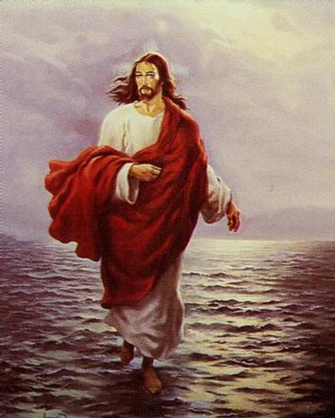

God? Man? All of the Above?
Back to Basics – Part 4
September 5, 2010

